Accelerated 1
Spring Student Enrichment Packet



PRINCE GEORGE’S COUNTY PUBLIC SCHOOLS
Office of Academic Programs
Department of Curriculum and Instruction

™

NOTE TO THE STUDENT

This Spring Student Enrichment Packet has been compiled to complement middle school mathematics classroom instruction aligned to the Maryland College and Career Ready Standards (MCCRS). The packet is intended to be used for review and practice of previously taught and new concepts.


The questions in this packet, which have the corresponding Maryland College and Career Ready standard listed next to them, are similar to those you will encounter later this year on the PARCC assessment. See more resources for PARCC at www.parcconline.org.

We strongly encourage you to work diligently to complete the activities. You may experience some difficulty with some activities in this packet, but we encourage you to think critically and creatively and complete them to the best of your ability.

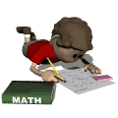

Use this Assessment Reference Sheet as needed as you solve the problems in this packet.

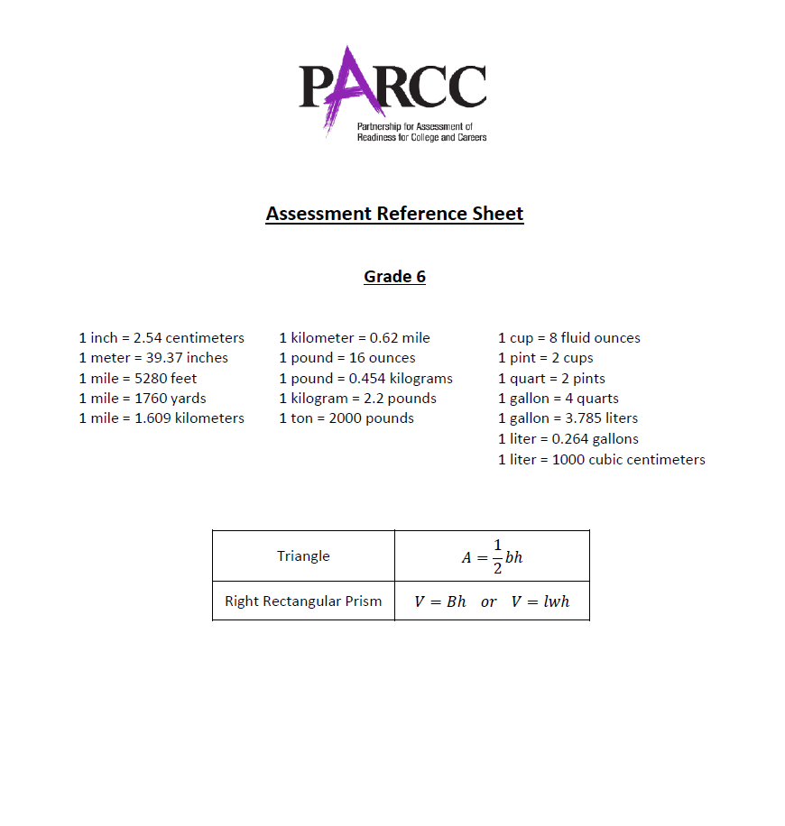

Directions: Select or find the best answer to each problem. Write your answer in the space provided or on a separate sheet of paper.

1. (6.RP.3)

James works in the paint department of a store. He made the chart below to determine how to make different amounts of orange. Use the following rules to determine the amounts of red and yellow paint needed to make the different amounts of orange.

To make orange: the amount of red paint is two times the yellow paint.

Complete the chart using the rule:

Number of Quarts
Red | Yellow | Orange
1.5
 | 3.5
9

2. (7.NS.1)

During one year, the highest temperature was recorded in July at a record 106° F. The lowest temperature recorded was in January at a low of −17° F. What was the difference between the recorded high and recorded low temperatures? Write your answer in the blank.

Difference: _______

3. (7.NS.1)

If −2 is added to any number, the result is always:

A. less than the original number
B. greater than the original number
C. even
D. a positive number

4. (6.RP [Securely Held])

A company sells small and large photo books. Each page of a small photo book costs the same.

The table shows the relationship between the number of pages in a small photo book and the total cost of the photo book.

Small Photo Book

Number of Pages | Total Cost ($)
10 | 15
18 | 27
 | 36

Part A
What is the cost per page for a small photo book? Enter your answer in the blank.

$ ________

Part B
How many pages are in a small photo book that costs $36? Show or explain how you determined your answer.

Part C
Each page of a large photo book costs 40% more than each page of a small photo book. What is the cost for a large photo book with 30 pages? Show or explain how you determined your answer.

5. (6.EE.9)

Gina is a costume designer for a local theater group. She kept track of the group’s total expenses and found that jewelry expenses were three times that of make-up expenses.

Part A
Complete the table for the expenses shown below.

Expenses
Make-up | Jewelry
 | 30
25
 | 90

Part B
Write an equation expressing the relationship between the expenses. Use the variables m for make-up and j for jewelry.

Part C
Using the coordinate grid, show the correspondence between make-up and jewelry expenses. Determine a scale, then label each axis and plot the points (ordered pairs) from the table.

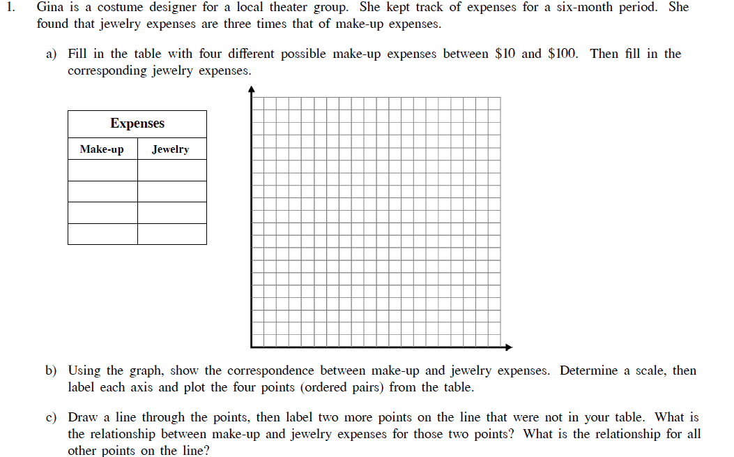

Part D
Identify two more points on the line that were not in the table but could have been added to the table. Write down the ordered pairs below.

( ____ ), ( ____ ) and ( ____ ), ( ____ )

6. (6.NS.4)

Suppose 10 is a factor of a ▪ b and 8 is a factor of b ▪ c, where a, b, and c are integers. What is the largest number that must be a factor of a ▪ b ▪ c?

A. 10
B. 20
C. 40
D. 80

7. (6.NS.8)

How far is the point (–5, –7) from the point (–5, 4)?

A. 4 units
B. 7 units
C. 11 units
D. 12 units

8. (6.RP.3a)

The table below shows equivalent ratios of a : b. Which of the following choices should go in the place of the missing number?

a | 8 | 12 | 28
b | ? | 21 | 49

A. 14
B. 15
C. 16
D. 17

9. (6.EE.8)

Given these inequalities:

- 3x – y < 5
- 2x – 3y > −2
- x – 6y ≥ −28

The ordered pair (2, 5) is a solution to:

A. I only
B. II only
C. I and III
D. I, II, and III

10. (6.RP.3b)

Which of the following statements below are true? Select all that apply.

□ A. A truck traveling 55 mph will cover a distance of 550 miles in 10 hours at that same rate.
□ B. A boat that travels 3 miles every 20 minutes will cover a distance of 9 miles in one hour at that same rate.
□ C. Walking a mile in 12 minutes is the same as walking 6 miles per hour at that same rate.
□ D. A cyclist going at a rate of 2 miles every 15 minutes will travel 8 miles in one hour at that same rate.
□ E. A car that travels a 4 miles in 6 minutes will travel 30 miles in 50 minutes at that same rate.

11. (6.EE.1)

When simplifying the following problem using the order of operations, which operation should be performed first?

11 ÷ (12 – 8 × 3) + 24

A. 11 ÷ 12
B. 12 – 8
C. 8 × 3
D. 3 + 24

12. (7.RP.3)

Janet researched the admission data of four universities and displayed it in a table.

University | Applications | Admissions
Syracuse | 25,884 | 12,779
Arizona | 26,629 | 20,068
North Carolina | 22,288 | 7,552
Kentucky | 13,537 | 9,275

Syracuse |  | Arizona |  | North Carolina |  | Kentucky

Place the school names above and in order from the lowest admissions percentage to the highest by placing their names in the spaces below.

____________ ____________ ____________ ____________

13. (7.EE.1)

An expression is given.

$$-4x+\frac{5}{4}y+\frac{3}{2}$$

Which are equivalent to the given expression? Select each correct answer.

□ $4\left(-x+5y+\frac{3}{8}\right)$
□ $2\left(-2x+\frac{5}{2}y\right)+\frac{3}{2}$
□ $4x-\frac{5}{4}y-\frac{3}{2}$
□ $2(\frac{3}{4}+\frac{5}{8}y-2x)$
□ $-4x+2(\frac{3}{4}y+\frac{1}{2})$

14. (7.RP.2c)
A sound wave travels through 40 km of water in 25 seconds. Which equation represents the relationship between t, the time in seconds, and d, the total distance the sound wave travels?

A. $d=\frac{5}{8}t$
B. $d=1\frac{3}{5}t$
C. $d=15t$
D. $d=65t$

15. (7.RP.2b)

Select the company that has the greatest hourly pay rate.

A. Company P pays an employee $70 for 8 hours of work

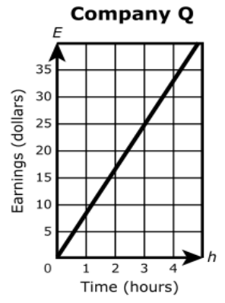
B.

C. Company R calculates the earnings of an employee, E, for working h hours using the equation E = 8h

D. Company S pays employees according to the information in the table.
Time, h  (hours) | Earnings, E  (dollars)
0 | 0
3 | 25.5
5 | 42.5

