Math 6
Spring Student Enrichment Packet



PRINCE GEORGE’S COUNTY PUBLIC SCHOOLS
Office of Academic Programs
Department of Curriculum and Instruction

™

NOTE TO THE STUDENT

This Spring Student Enrichment Packet has been compiled to complement middle school mathematics classroom instruction aligned to the Maryland College and Career Ready Standards (MCCRS). The packet is intended to be used for review and practice of previously taught and new concepts.


The questions in this packet, which have the corresponding Maryland College and Career Ready standard listed next to them, are similar to those you will encounter later this year on the PARCC assessment. See more resources for PARCC at www.parcconline.org.

We strongly encourage you to work diligently to complete the activities. You may experience some difficulty with some activities in this packet, but we encourage you to think critically and creatively and complete them to the best of your ability.

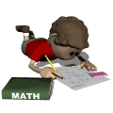

Use this Assessment Reference Sheet as needed as you solve the problems in this packet.

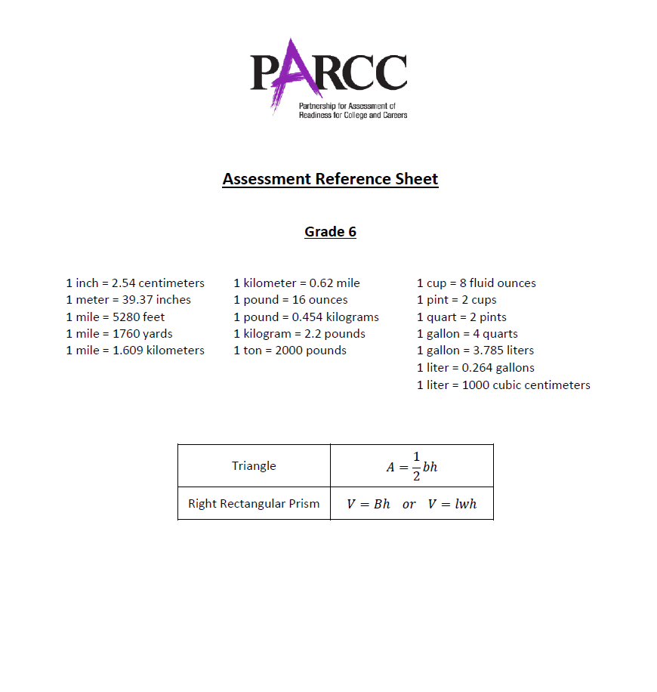

Directions: Select or find the best answer to each problem. Write your answer in the space provided or on a separate sheet of paper.

1. (6.RP.3)
The Fuller family wants to drive to a national park. Some information about their trip is given in the table below.

Distance to national park | 515 miles
Car’s gas tank capacity | 20 gallons
Average gas mileage for car | 26 miles per gallon

The family wants to determine if they can drive to the national park using just one tank of gas in their car. Determine whether the Fullers can reach the national park. Show your work or explain your answer.

2. (6.NS.6)

How many units is the point (–3, –8) from the point (9, –8)?

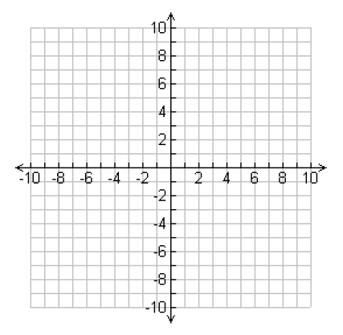

A. 3
B. 6
C. 9
D. 12

3. (6.EE.3)

Which of the following expressions is equal to (7b)c?

A. 7b + c
B. 7b + 7c
C. 7 + bc
D. 7(bc)

4. (6.RP.3)

The table shows the rate to process potatoes into french fries at one plant.

Minutes | 5 | 15 | 25 | 40
Potatoes (lbs.) | 150 | 450 | 750 | ?

At this rate, how many pounds of potatoes does the plant process into french fries in 40 minutes? Enter your answer in the box.

pounds

5. (6.EE.2)

Translate the following phrase into an expression. Use the tiles below to fill in the blanks. You may use each tile more than once if needed.

the quotient of n and four decreased by one

+ |  | – |  | x |  | ÷ |  | n |  | 4 |  | 1

_________ _________ _________ _________ _________

6. (6.EE.2)

The profit on a jacket can be found by the formula P = 24x – 125, where x is the number of jackets sold. What is the profit if 15 jackets are sold? Enter your answer in the box.

$

7. (6.RP.3)

Terrence had some problems to complete for math homework. He completed six problems, as shown in the diagram, which represented 40% of the problems he had to do in all. How many problems does he have altogether for homework? Enter your answer on the line below.

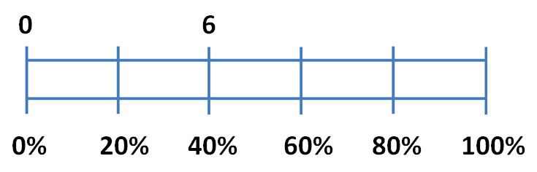

Terrence had to do ____ total problems for homework.

8. (6.NS.1)

The area of a rectangular patio is $2\frac{13}{16}$ square yards. If the patio is $\frac{7}{8}$ of a yard long, then how wide is the patio? Enter your answer below.

9. (6.RP.1)

A class of 32 students shares a class set of 78 colored pencils. On a day with six students absent, which statement is true?

A. For each student, there are 4 colored pencils.
B. For each student, there are 3 colored pencils.
C. For every 3 students, there is 1 colored pencil.
D. For every 4 students, there is 1 colored pencil.

10. (6.NS.1)

The table shows the portion of time you spent on several activities during your class’s field trip to an amusement park.

Activity | Fraction of time spent
Going on rides | $$\frac{1}{6}$$
Waiting in lines for tickets | $$\frac{3}{10}$$
Playing basketball | $$\frac{1}{12}$$
Completing the math and science activities | $$\frac{3}{10}$$
Riding water rides | ?
Having lunch | ?

Part A
How many times more is the fraction of time spent waiting in lines for tickets than the fraction of time spent playing basketball? Show your work or explain your answer.

Part B
The portion of time riding the water rides is two times more than the portion of time spent having lunch. What fraction of your time at the park was spent riding? What fraction of your time was spent having lunch? Show your work or explain your answer.

11. (6.EE.2)

Given the expression below, select the correct words from the boxes to complete the sentences below.

$$4x-7+2y$$

- coefficient.
- constant.
- variable.
- coefficient
- constant
- variable
In the expression, 7 is considered a and 4 is considered a

- two
- three
- five

Altogether, this expression has terms.

12. (6.EE.6)

Carly took $21.25 to a carnival. Each ride ticket costs r dollars at the carnival, and Carly bought 4 ride tickets. Which expression represents the amount of money, in dollars, that Carly had after she bought the tickets?

A. 21.25 – 4r
B. 21.25(4) – r
C. 21.25r – 4
D. 21.25 – (4 + r)

13. (6.EE.1)

Which equations with exponential expressions are true? Select all that apply.

□ A. $4^{4}=4×4$
□ B. $5^{4}=5×5×5×5$
□ C. ${3×2=2}^{3}$
□ D. ${ 6}^{4}=6×6×6×6$
□ E. $3^{1}=3$
□ F. $3^{7}=7×7×7$

14. (6.NS.3)

Marcie is trying to drink 2.5 liters of water a day. She drinks 0.878 liters after breakfast, 1.2 liters after lunch and 0.75 liters before dinner. How much did she drink all together? Enter your answer in the box.

total liters

15. (6.NS.6)

Plot the points that are five units from Point A that share the same y-coordinate as Point A. Plot all points that apply. Select the places on the coordinate grid to plot the points.
