Grade 1
MATHEMATICS
WINTER STUDENT
ENRICHMENT PACKET

™

Prince George’s County Public Schools
Office of Academic Programs
Department of Curriculum and Instruction

Directions and Notes
for Students and Parents
Grades 1 - 5
1. Plan to work for about one hour to complete the entire packet.

2. Find a quiet place to complete your work independently.

3. Read each problem carefully before selecting or writing your answer.

4. Check your work.

Thank you for helping your child succeed!

Winter Fun
- Create number sentences to show four ways that you can eat 18 cookies. 1.OA.3, 1.OA.6
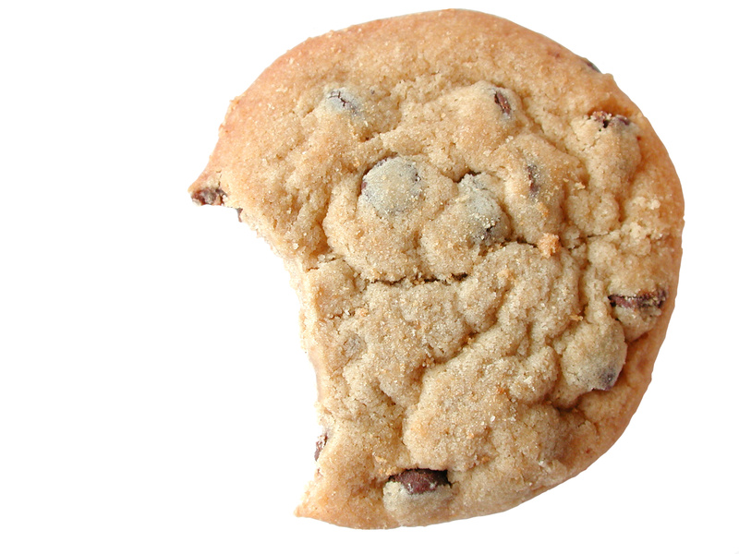
- ____ + ____ = ____ b) ____ + ____ = ____
c) ____ + ____ = ____ d) ____ + ____ = ____
2. Place red and blue hats on the snowmen below to create two different ways to show 10. 1.OA.6
First way
____ + ____ = 10
How many snowmen have no hat? _________
_______________________________________________
Second way
____ + ____ = ____
How many more snowmen do you need to have another 10? _______

3. A group of 15 children went out to play. Complete the paragraph with numbers that show 15 children went out to play. Read your story to a family member when you are finished. 1.OA.1

There were _______ girls  in the group and ________ boys. 
Each of the girls wore bright red mittens, so there were ________red mittens.
The boys all wore green mittens, so there were
_________ green mittens.

Complete the chart:
Number of children
Number of girls
Number of boys
Total number of mittens in all
Total pairs* of mittens
Total number of fingers in all

*A pair is equal to two.

4. Write a story problem that can be solved by using the number sentence 8 + 6 = ______. 1.OA.8

5. Write a story problem that can be solved by using the number sentence 14 - 7 = ______. 1.OA.4

6. Which doubles fact can help you solve this problem? 5 + 6 = 11 1.OA.6
Explain how the fact that you chose can help. _______________________________________________
____________________________________________________________________________________

7. Use the number line above to show three numbers that will add up to 20. Write the number sentence that matches your picture in the space below. 1.OA.2, 1.OA.8
_______+_______ + _______ = 20

8. What number is missing in the pattern below? Write the number on the blank space. Then, write a sentence explaining why you chose that number. 1.NBT.5
15, ___, 35, 45, 55
Use numbers, words, and/or symbols to explain how you found your answer.

9. Look at the number sentences below. Circle the ones that are true. 1.NBT.3
16 > 20 10 < 5 3 < 7 12 > 10 8 > 8
On the lines below, rewrite the incorrect comparisons using the correct symbol. Then, explain how you know your answer is correct.

10. Sort all these shapes into two groups so that each group has something in common. Show how you grouped the shapes by writing the letter/number from each shape into the boxes marked Group 1 and Group 2. Then, write a sentence that explains how you decided to group the shapes. Write a number sentence to show how many shapes there are in all. 1.G.1

Group 1 | Group 2

A

7

9

M

2

S

