WINTER STUDENT ENRICHMENT PACKET
GRADE 2

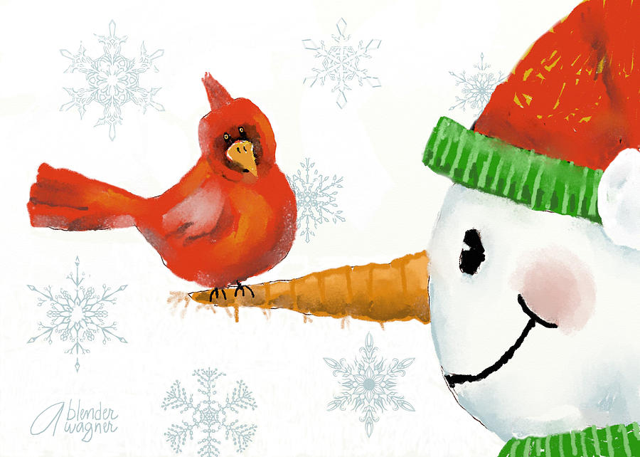

Elementary Reading/English Language Arts and Social Studies

™

Prince George’s County Public Schools
Office of Academic Programs
Department of Curriculum and Instruction

SECOND GRADE WINTER STUDENT ENRICHMENT PACKET

Note to Students:
You’ve learned a great deal already this school year! It is important that you keep your brain active over the Winter Break. In this packet, you will find activities to last until you return to school. When you’re not sledding, or drinking hot chocolate, complete this packet so you will get off to a good start in the New Year!

DIRECTIONS

Complete each activity in the Winter Student Enrichment Packet. Write your responses in the spaces provided.

Parents are encouraged to assist in the following ways:

- Make a plan to complete the activities during the Winter Break.

- Provide a quiet space and time for your child to work on the homework.

- Help your child with the directions and with completing the activities.

- Review and discuss your child’s responses. Provide positive feedback and praise for sincere effort and independence.

- Encourage daily reading of 20-30 minutes of a self-selected book. Read to your child, listen to him/her read, or share the reading.

Thank you for helping your child succeed!

Reading Comprehension Directions
Literary Text

Please read the following directions with your child.

- Before reading, talk about times when you think people in neighborhoods could work together.

- Read the story carefully. First, read the story silently. Then, read the story out loud.

- After reading, complete the following questions using the passage and the My Response Page given in this packet.

- Read each selected response question. Refer back to the text to help you with each question.

- Think about Predicting Outcomes. Remember that when you predict outcomes you use story details and what you already know to make predictions. Even though, the story is complete, explain what you think will happen next in Millie’s neighborhood.

Millie’s Garden
by Pam Zollman

Grade 2: Theme 3: Around Town: Neighborhood and Community
Adapted from Houghton Mifflin Reading
Houghton Mifflin Company

Millie loved her neighborhood, but she didn’t love the way it looked. Bottles, paper, and tires were everywhere so she decided to do something about the mess.
Millie had lots of friends. But when she asked them to help clean up the empty lot of trash, tires, and furniture, no one wanted to help.
“Impossible!” said Mrs. Brown from her porch.
“Too tired,” said Mr. Abrams, a grocery store owner.
“No time,” said Mrs. Jordan as she hung clothes on the line.
“Too hot,” said Tamika, her face damp with sweat.
“Too hard,” said Hector as he watched reruns on TV.
So Millie picked up the trash by herself. John was bored, so he helped Millie move the sofa and old tires to one side. They turned in the cans, bottles, and papers to the recycling center and used the money to buy seeds.
Millie had lots of friends. But when she asked them to help her mow and weed the vacant lot, only John helped.
“Impossible!” said Mrs. Brown from her porch.
“Too tired,” said Mr. Abrams as he worked the cash register.
Mrs. Jordan and her young children brought marigolds from their yard for Millie’s garden. The vacant lot turned green and gold as vegetables grew.
Millie had lots of friends. But when she asked them to help pick vegetables, only John, Mary, and Mrs. Jordan and her young children helped.
“Impossible!” said Mrs. Brown from her porch.
Mr. Jones yawned as he walked home from his store. Then he took a nap. When he awoke he felt refreshed, so he made a sign that read “Fresh Vegetables for Sale Here.” Mr. Jones helped Millie, John, Tamika, and Mrs. Jordan and her children sell the vegetables.
From her porch, Mrs. Brown watched everyone work together. “It is possible!” she exclaimed. She drove over in her pickup truck.
Millie, Hector, Tamika, Mrs. Jordan and her young children, and Mr. Jones loaded the sofa and tires into Mrs. Brown’s truck. Then, Mrs. Brown drove to the dump.
Now the empty lot looked beautiful.
Millie had lots of friends. When she asked them to help plant new seeds, everyone wanted to help.
After all, it wasn’t just Millie’s garden anymore.

Millie’s Garden
MY RESPONSE PAGE

1. Based on the passage, which word best describes Millie?
- a. funny
- b. brave
- c. determined
- d. mean

2. A summary for this passage could be____________________.

- a. Millie did not like how her neighborhood looked, so she told her Mom she wanted to move.
- b. Millie liked her neighborhood and spent most of her time visiting the neighbors.
- c. Millie did not like how her neighborhood looked, so she asked everyone to help and they refused.
- d. Millie did not like how her neighborhood looked, so she asked everyone to help and, eventually, they did.

3. Based on what you have read, explain what you think will happen next to the garden. Include details from the passage to support your explanation. (Use additional paper as needed.)
____________________________________________________________________________________________________________________________________________________________________________________________________________________________

4. Draw and label a picture that shows an important event in the story. Write a sentence about it below the box.

Reading Comprehension Directions
Informational Text

Please read the following directions with your child.

- Before reading, talk about what you already know about creatures of the sea. Talk about some information you already know about an octopus.

- Read the story carefully. First read the story silently. Then, read the story out loud.

- After reading, complete the following questions using the passage and the My Response Page given in this packet.

- Read each selected response question. Refer back to the text to help you with each question.

- Think about the title. Remember good readers think about the title the author has chosen to give to the passage. Do you think this was a good title? Explain why or why not. (Answer the question on the attached response page.)

- Write a short story about you and an octopus at sea. Use your imagination and the information you learned from the passage in your story. When you finish your story and your illustration, read your story aloud to someone.
An Octopus Is Amazing
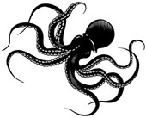
by Patricia Lauber
Grade 2: Theme 4: Amazing Animals
Adapted from Houghton Mifflin Reading
Houghton Mifflin Company

An octopus is a sea animal. It has a soft, bag-shaped body and eight rubbery arms. There are many kinds of octopus. They like to live alone. Its den is just big enough for its body. An octopus can fit into a small space because it has no bones.
An octopus can change color in a flash. Changing color helps an octopus hide or escape from enemies that are trying to eat it. The octopus no longer looks like the animal the fish was going to attack. An octopus can also give off a black ink liquid through its special tube. The ink forms a shape that looks and smells like an octopus. The enemy attacks the shape, and the octopus escapes. Its color may also show how an octopus is feeling. An angry octopus turns dark red. A scared one turns pale.
An octopus eats crabs, lobsters, and clams. Sometimes an octopus waits in its den until a crab or lobster passes by. Then it reaches out an arm and grabs its dinner. The octopus holds its food with its suckers and examines it. Inside its mouth is a hard, curved beak that is used to break open the shell.
An octopus may also leave its den and hunt for food. The octopus uses the suckers on its arms to hold on to rocks and pull itself forward. Or it may move quickly, by shooting water out of its body through a tube. With each spurt, the octopus jets through the sea.
An octopus is truly amazing!
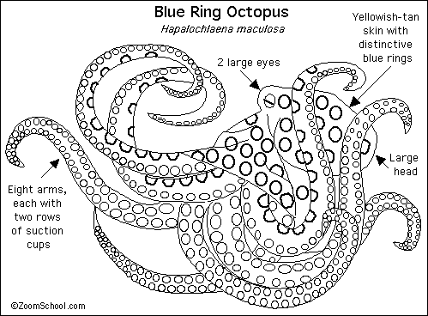
This is a diagram of the Blue Ring Octopus.
An Octopus Is Amazing
MY RESPONSE PAGE

4. Which of these sentences is NOT a fact about an octopus?
- a. An octopus is truly amazing!
- b. An octopus can also give off a black ink liquid through its siphon.
- c. A frightened octopus can turn pale.
- d. Inside an octopus’ mouth, it has a hard, curved, beak.

5. According to the text, why does an octopus change color?
- a. Changing color helps an octopus give off a black ink liquid.
- b. Changing color helps an octopus hide or escape from enemies.
- c. Changing color helps an octopus find its den.
- d. Changing color helps an octopus to pull itself forward.

6. Do you think An Octopus Is Amazing is a good title for this article? Use details from the text to support your answer. (Use additional paper as needed.)
_________________________________________________________________________________________________________________________________________________________________________________________________________________________________________________________________________________________________________________________________________________________________________________________________

Writing Prompt
Pretend you are stranded at sea. You notice there is an octopus nearby. Write a short story about what happens next.
In your story be sure to:
- tell how you got stranded at sea
- use some information from the article when describing the octopus
- tell how you are able to make it home
- think of a good title for your story
- draw and color a picture about your adventure on the back

Title: ______________________________
________________________________________________________________________________________________________________________________________________________________________________________________________________________________________________________________________________________________________________________________________________________________________________________________________________________________________________________________________________________________________________________________________________________________________________________________________________________________________________________________________________________________________________________________________________________________________________________________________________________________________________________________________________________________________________________________________________________________________________________________________________________________________________________________________________________________________________________________________________________________________________________________________________________________________________________________________________________________________________________________________________________________________________________________________________________________________________________________
________________________________________________________________________________________________________________________________________________________________________________________________________________________________________________________________________________________________________________________________
________________________________________________________________________________________________________________________________________________________________________________________________________________________________________________________________________________________________________________________________________________________________________________________________________________________________________________________________________________________________________________________________________________________________________________________________________________________________________________________________
________________________________________________________________________________________________________________________________________________________________________________________________________________________________________________________________________________________________________________________________
________________________________________________________________________________________________________________________________________________________________________________________________________________________________________________________________________________________________________________________________________________________________________________________________________________________________________________________________
________________________________________________________________________________________________________________________________________________________________________________________________

VOCABULARY ACTIVITIES
Select one of the Vocabulary Activities to complete.
#1 Homophones Activity
Homophones are words that sound alike but have a different meaning. Look at the example below.
fly  The fly is on the window. | 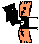  fly  This boy thinks he can fly like Superman.
Read the words in the word box. Select at least four pairs of homophones. Create a homophone flipbook. For each pair you select, write a sentence and draw a picture for each.

clean | some | right | sang | peace | one
knight | add | story | ate | flower | won
see | pair | flour | sum | ad | hear
write | eight | here | bee | at | fun

#2 Vocabulary Map

den | empty | scared
attack | escape | examine
 | amazing | exclaim

You read the story, Millie’s Garden, and the article, An Octopus Is Amazing. Below are some vocabulary words from both passages. Complete a Vocabulary Map for one of the selected words (see example attached).
WORD BOX

Name: _______________________________________Date: ___________________________
Sample Vocabulary Map

inspect
(synonym)

1

The octopus holds its food with its suckers and examines it.

From: An Octopus is Amazing
(sentence or phrase from the text)

glance
(antonym or non-example)

examine
Vocabulary Word

to study somebody or something in detail

(matching dictionary
definition)
Name: ________________________________________ Date: ___________________________
2
8
4
3
6
5

examined
examining

(other forms of the word)
7



(my association, examples, or illustration)

The boy is excited because he is using his new telescope to examine the stars.

(my very own sentence)
Vocabulary Map

(synonym)

1

From: ________________________
(sentence or phrase from the text)

(antonym or non-example)

Vocabulary Word

(matching dictionary
definition)
5
4

6
3

(other forms of the word)

2

8

(my very own sentence)

7

(my association, examples, or illustration)

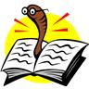
Reading Log for Winter Break: Grade 2

Read for a minimum of 15 minutes each day of the Winter Break.

Date | Title | Author | Pages Read | Minutes Read

