Grade 8 Science
Winter Enrichment Packet
STUDENT BOOK




Prince George’s County Public Schools
Office of Academic Programs
Department of Curriculum and Instruction

Note to Parents and Students

This is an at-home science student instructional packet for Winter Break. This packet has been created to provide practice for students to answer Selected Response (SR) items and work through technical reading passages of informational text to support elementary science and the PGCPS Literacy Initiative.

- For more information about the PGCPS Literacy Initiative, visit: http://www.pgcps.org/literacy/ for parents and students.

Students will use the passages to write claims, evidence, and reasoning for Brief Constructed Response (BCR) items and to answer Selected Response (SR) items. Please write your responses to the SRs and BCRs on the space provided in this booklet.

It is highly recommended that students practice their annotating skills when reading the text.

The items in the Winter Break Packet are related to earth and space science, physical science and life science concepts that are aligned to the Next Generation Science Standards (NGSS).

For more information about the PGCPS Science and NGSS, visit:
- PGCPS Science Department: http://www1.pgcps.org/science/
- NGSS Website: https://www.nextgenscience.org/
- NGSS Parent Guide: https://tinyurl.com/NGSSParentGuide

The packet should be used for review purposes in preparation for the new Maryland Integrated Science Assessment (MISA). MISA is administered during the months of March and April.

Enclosed in this packet, is a “Claim, Evidence, and Reasoning Rubric for Writing,” retrieved from the National Science Teachers Association (NSTA) for students to self-assess their BCRs responses.

Several articles, questions and images were retrieved from Readworks.org. ReadWorks® is a Registered Trademark | © 2017

The answer key and writing rubric are located on the last page of this packet.

Physical Science

Use the reading passage to answer items 1, 2, and 3.

Mix the Old with the New

Chefs in busy restaurants do a lot of different things. They check the inventory of ingredients used for each popular dish. They may supervise a kitchen staff, making sure their assistants are working well as a team. They may also ensure that diners are not waiting too long for their food.

Chefs may taste the food before it leaves the kitchen. They do a lot and think about everything that goes into the food and the experience their restaurant provides. But, they may not think about how they and their staff change the properties, structure, and state of matter of food...but they are doing that with many dishes they serve.

Do you know how to change the properties, structure, and state of matter of a substance? If you have made ice before, the answer is yes. When you put an ice tray filled with water in a freezer, the temperature of the water in that ice tray lowers. The freezer makes a physical change of state to the water by turning it from a liquid to a solid.

When we cook, we change many things about the food we are preparing. These could be any number of properties: size, shape, mass, color, or temperature. We can change the physical or chemical nature of the food. We can even change the state of matter the food is currently in to another state of matter.

STATES OF MATTER
There are four common states of matter we see almost every day: solid, liquid, gas, and plasma. We can observe all four of them in a kitchen. A solid is as simple as an ice cube, or frozen water. Melt that ice cube, and you produce water, a liquid. Boil that water, and you produce steam, or water vapor. Believe it or not, plasma can be found in kitchens too. It’s found in fluorescent lights, neon signs, and plasma televisions. Other examples of plasma include the sun and lightning.

CHEMICAL CHANGES
A chemical change produces something from other materials and occurs on the molecular level. Some examples of chemical changes that take place in a kitchen are frying an egg, grilling fish, or burning that egg or fish. When you smell onions sautéing in a pan or catch a whiff of the chicken roasting in the oven, the scent coming from the food is also a chemical reaction. Hopefully, the scents you smell are only appetizing ones. There are undesirable chemical changes that occur in the kitchen, too. If you smell the odor of rotting food, you’ve got a chemical change that needs some addressing!

After you wash your metal pots and pans, make sure they dry properly. If they don’t dry, the metal could react to the oxygen in the air and rust. Rust is evidence of another chemical change you don’t want in your kitchen.

PHYSICAL CHANGES
Physical changes in the kitchen do not produce a new substance. Changes in state or phase are physical changes. For example, cutting vegetables, or even dissolving salt in a hot soup are examples of physical changes. In general, physical changes can be reversed using physical means. In the example of dissolving salt in a hot soup, evaporating the water naturally or applying heat to boil off the water can return the salt to its original state of matter.

When water is boiled, steam is created. That steam is water vapor, or the gas phase of water. That change from a liquid to a gas is an example of a physical change. Let’s say you’re making a smoothie with strawberries, bananas, kale, and orange juice. When you’re cutting the fruits and vegetable into smaller pieces, it’s a simple physical change. When you add them to the blender with the orange juice, the physical change that takes place during blending is more complex, and you now have a liquid. You can even go full-circle and turn your liquid smoothie into a solid by turning it into popsicles in the freezer.

A DIFFERENT KIND OF COOKING
There are some chefs in this world who reject or reinterpret traditional cooking techniques and cuisines. They push the boundary of food with new techniques to create entirely new combinations of flavor and texture. They take states of matter, physical changes, and chemical changes of food to a whole different level.

MOLECULAR GASTRONOMY
While some chefs may not actively think about the science behind the food they serve, others are using a modern style and science of cooking called molecular gastronomy. Molecular gastronomy is a scientific discipline that studies the physical and chemical processes that occur while cooking. Chefs who practice molecular gastronomy study and apply scientific principles when cooking and preparing their dishes. Their goal is to use their knowledge to make a tasty and unique dining experience.

They are concerned about how to make food delicious as well as what makes food delicious. To understand this, they have to consider many factors. Some of these factors include how their ingredients are grown, processed, and transported. Where did the seeds used to grow the fruit come from? What kind of dirt and how much water did this vegetable receive? After harvest, was it ever put in a plastic bag? Was it sent by air, truck, and/or boat? What negative effects did transportation have on the produce?

Only after all that is determined do many molecular gastronomy chefs finally get to the cooking part of their craft. They want to understand how ingredients change with different cooking techniques. They want to know how all of a person’s senses, not just taste, play into the enjoyment or dislike of food. They go deeper and learn how the brain interprets the signals our senses send to ultimately determine the flavor tasted. They even experiment with how food is presented, who prepares it, and what mood the diner is in.

Many of these factors are what most chefs consider anyway; but, what really differentiates molecular gastronomy chefs is in the preparation and presentation steps. And when it comes down to it, a molecular gastronomy chef is many things at once: a little physicist, a sprinkle of chemist, a dash of agriculturist, a spoonful of biologist, and a heap of psychologist to top it off! That’s a solid list of ingredients that hopefully turns into fun and tasty food.

PREPARATION
Molecular gastronomy chefs look at how ingredients are changed by different cooking methods. These cooking methods affect the eventual flavor and texture of food ingredients. One method is called direct spherification. This is the process of turning a liquid into little, caviar-like balls. Employing gelling solutions like sodium alginate, liquids like fruit and vegetable juices, and even milk, are dropped into calcium chloride and water to form a thin shell around the liquid. This jelly membrane creates the ball that pops with the liquid’s intense flavor when eaten.

The spheres are fragile and are usually served immediately. Another method is a variation on the existing technique of using foams. Well-known foams include whipped cream and mousse, and also involve the use of air or another gas to create a lighter texture and feel when eaten. A variation on the foaming technique is to make foam that is made of mainly air. You can make foams out of almost anything. It can have so much air that it resembles big soap bubbles. This changes the texture into something lighter while allowing the flavor to remain. Steak bubbles, anyone?

A recipe that combines the foam and spherification techniques is Apple Caviar with Banana Foam served on a spoon. Combining apple juice in the form of spheres and banana foam whisked with heavy cream, milk, sugar, and gelatin, this spoonful is not your typical dessert!

Some molecular gastronomy cooking methods involve temperature regulation. One method is called sous-vide and entails cooking food, like meats, in airtight plastic bags in a water bath. This ensures the entire piece of meat is cooked evenly and also retains its juices. Cooking times when using the sous-vide method don’t have to, but can increase dramatically.

Some chefs choose to tenderize tough meats like beef brisket with a sous-vide water bath that lasts for two to three days. Although it may seem like weird science (or just being plain ridiculous), molecular gastronomy chefs want to explore new possibilities in the kitchen. Combining new and old cooking techniques, new equipment and technologies, and various sciences, these chefs may be inventing the food of the future. Whether they are successful or not, they are definitely making things fun.

GOOD FOOD IS GOOD FOOD
Whether a chef uses traditional or new cooking methods, the fundamentals of cooking are the same. Both traditional and molecular gastronomy chefs change the properties of the food they serve. They change the states of matter, properties, and structure of food to, hopefully, serve a great meal. © 2012 ReadWorks®, Inc. All rights reserved.

A change in the state of matter of something is an example of a physical change.
Solid, liquid, gas, and plasma are states of matter.

1. What can be concluded from this information?

- Changing water from liquid to solid is an example of a physical change.
- Changing water from liquid to solid is an example of a chemical change.
- Frying an egg and grilling a fish are both examples of physical changes.
- Changing water from liquid to gas is an example of both a physical change and a chemical change.

2. What kind of changes do chefs make to food?

- Chefs make chemical changes only.
- Chefs make physical changes only.
- Chefs never make any changes to food.
- Chefs make chemical and physical changes.

3. How does knowing about the physical and chemical changes of food affect the work of a
molecular gastronomy chef? Provide an explanation using evidence from the reading passage. Write in the space provided below.

Earth and Space Science

Use the reading passage to answer items 4, 5, and 6.

Water is Everything
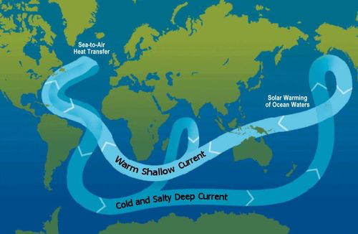
Water is vital for our existence. Not only do we drink it for survival, the majority of the human body is also composed of water. The earth’s weather patterns are closely linked to water too, as they are determined by the complex patterns of changes and movement of water in the atmosphere. Since the ocean covers 70% of the earth’s surface, it plays a major role determining what happens in the environment. One of its most important roles is distributing the heat around the world; it soaks up energy in the form of heat, and releases it more evenly across the earth.

Water and Temperature

Since the ocean is so effective at absorbing heat, the first few meters of the ocean’s surface hold as much heat as the earth’s entire atmosphere. But how does water control the earth’s weather? First, it’s important to know that the temperature of the water in the ocean and its salt content affect the water’s density. So, the saltier or the colder the water, the denser it is. Denser water sinks to the bottom of the ocean, while less dense water floats at the surface. The temperature of water is closely related to ocean currents, since the former affects the latter.

Ocean Currents
Simply put, ice triggers the movement of ocean currents. As water freezes in the North and South Poles, the water surrounding the ice becomes saltier and colder, since the salt leaves the water upon freezing. The ice then cools the water surrounding it. The cold, salty water then sinks due to its increased density. Once it gets to the bottom of the ocean floor, it has to move somewhere, so it travels horizontally to spread out over the surface of the earth. This is cold current. Warm water replaces it on the surface and moves to the North. This motion is called the global conveyor belt. The global conveyor belt is a global-wide current that circulates cold and warm water around the earth. So, the warm water that replaces the cold on the surface travels northward, increasing the temperature of the Atlantic Ocean. That’s why countries that border the Atlantic Ocean are relatively warmer than landlocked countries during the wintertime.
However, the cold water doesn’t always stay at the bottom of the ocean. Instead, it comes up at different places around the globe called upwelling. Since the ocean floor contains many nutrients important for survival, the cold water that rises to the surface brings these nutrients with it, attracting all forms of life. Usually every level of the food chain is present at these upwellings, making them great spots for fishing. In fact, upwellings are common in areas where winds blow water away from the surface. In coastal areas, sometimes winds (called longshore winds) blow perpendicular to the land over the ocean, pushing the warm water away from the coast. This allows the cold water at the bottom to rise up and replace the warmer water. Therefore, some coastal areas are effective places to fish due to the upwelling that attracts more fish to the area.

The Global Conveyor Belt
As previously mentioned, the global conveyor belt describes the current that runs throughout the earth’s waters, driven by the cold waters at the poles. The “belt” starts in the North Atlantic Ocean, where the cold water that surrounds the ice sinks, and starts to flow around the world. A current is created as warm water rushes to the surface to replace the sinking cold water. The cold, dense water moves southward in between the continents toward South America and Africa—and as it passes the equator, the water warms. As the water passes Antarctica, it is re-cooled by the ice near the South Pole. It continues to move on from there and splits into two paths: one that veers off toward the Indian Ocean, and the other toward the Pacific Ocean. These two paths gradually warm up as they travel northward, causing them to rise to the surface (which, as we know, is called an upwelling). The currents eventually return to the North Atlantic, where the journey begins again. Although the path of the global conveyor belt can be quickly explained, the actual travel time occurs very slowly—the waters travel at slow speeds when compared to tidal currents.

Ocean Currents and Climate
The effect that ocean currents have on the earth’s climate is still being studied by scientists around the world, but we know a few things for sure. The ocean plays a huge role in redistributing heat around the globe, like we previously explained. However, there are certain ocean currents, like the Gulf Stream (which is part of the global conveyor belt) that have a direct effect on the climates of countries they pass. The Gulf Stream travels past the Caribbean and Florida, carrying warm water, then turns off to the right toward Europe—specifically England and Ireland. That’s why the northeastern part of the United States and Canada has a cooler climate; the Gulf Stream doesn’t bring warm water to its shores, causing colder temperatures. And since the direction of currents is always affected by wind direction (like we previously described with upwellings), climate is indirectly affected by wind as well.

Global Warming
Scientific evidence has shown that the earth has warmed since 1880. Global warming is caused mainly by an increase in carbon dioxide levels in the atmosphere. The increased temperatures have caused many of the ice caps in the North and South Poles to melt, disrupting the global conveyor belt. Even though the phenomenon is called “global warming,” it is more accurately described as climate change—if the ice caps melt, there will be less dense water to move around the globe. And if there’s less dense (and therefore cold) water to circulate around the earth, the Gulf Stream will be slowed down. This will result in a cooling of the Caribbean and Western Europe. Thus, global warming can in fact result in colder temperatures in some areas.
© 2013 ReadWorks®, Inc. All rights reserved.

4. Use the reading passage to select the best answer choice that supports the statement, “Water is
vital for our existence.”

- Climate is indirectly affected by wind as well.
- Cold water doesn’t always stay at the bottom of the ocean.
- Global warming can in fact result in colder temperatures in some areas.
- Water plays a major role determining what happens in the environment.

5. When ice freezes, the water around it becomes saltier and colder.
Therefore, its density ________________.

- decreases
- stays the same
- increases
- disappears

6. Use the reading passage to explain that ice from the North Pole and South Pole cause movement of ocean currents? Be sure to provide evidence from the reading passage to support your claim. Write in the space provided below.

EARTH AND SPACE SCIENCE/PHYSICAL SCIENCE

Use the article to answer items 7, 8, and 9.
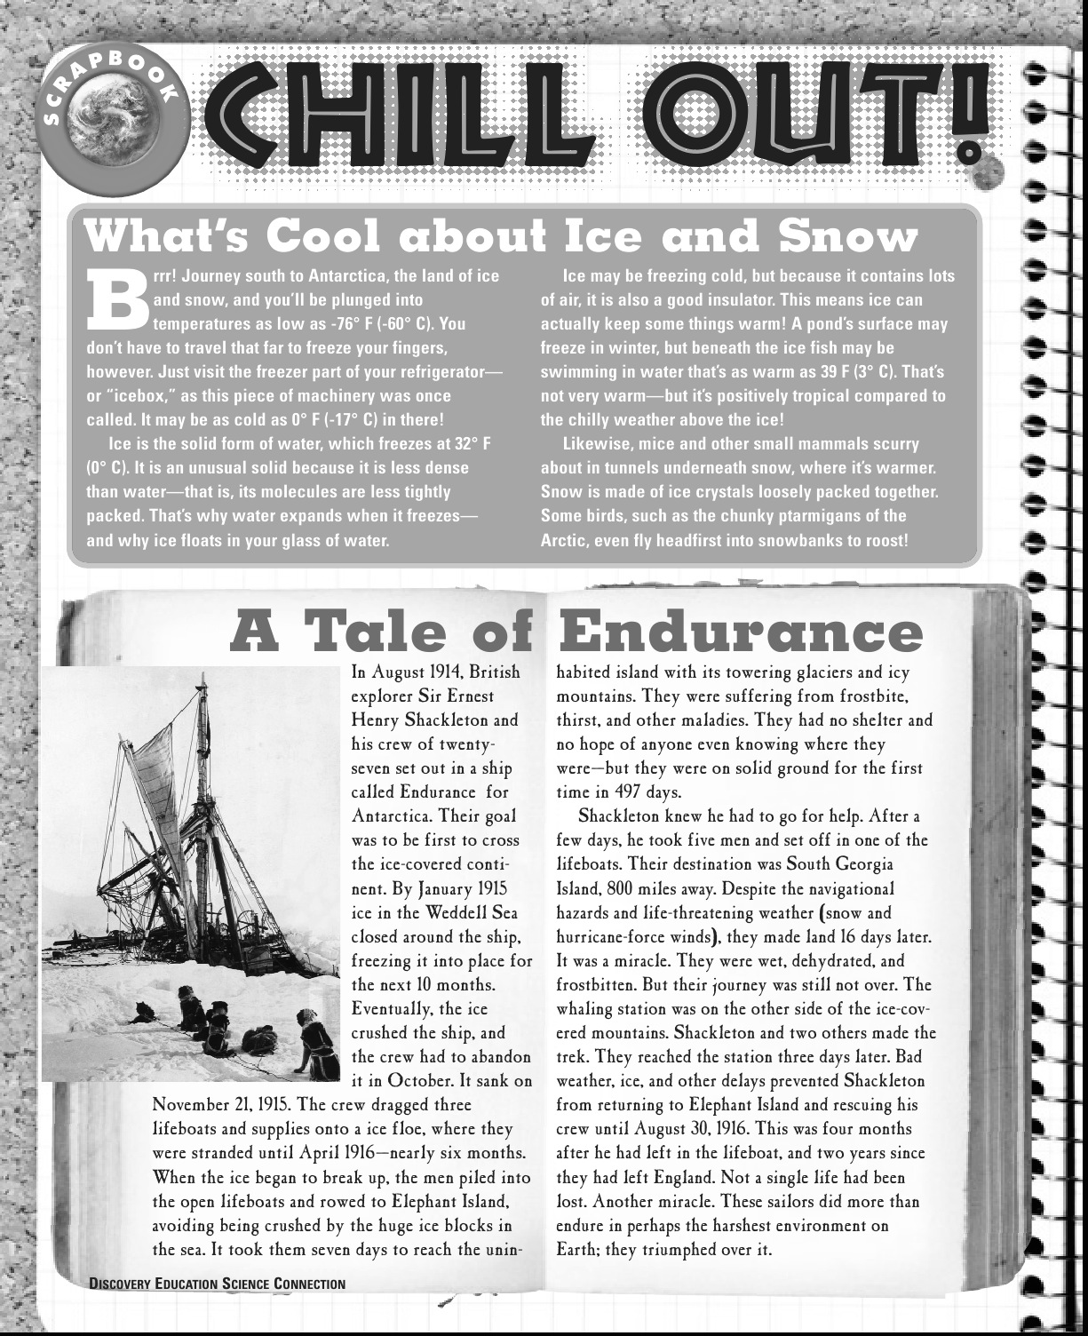

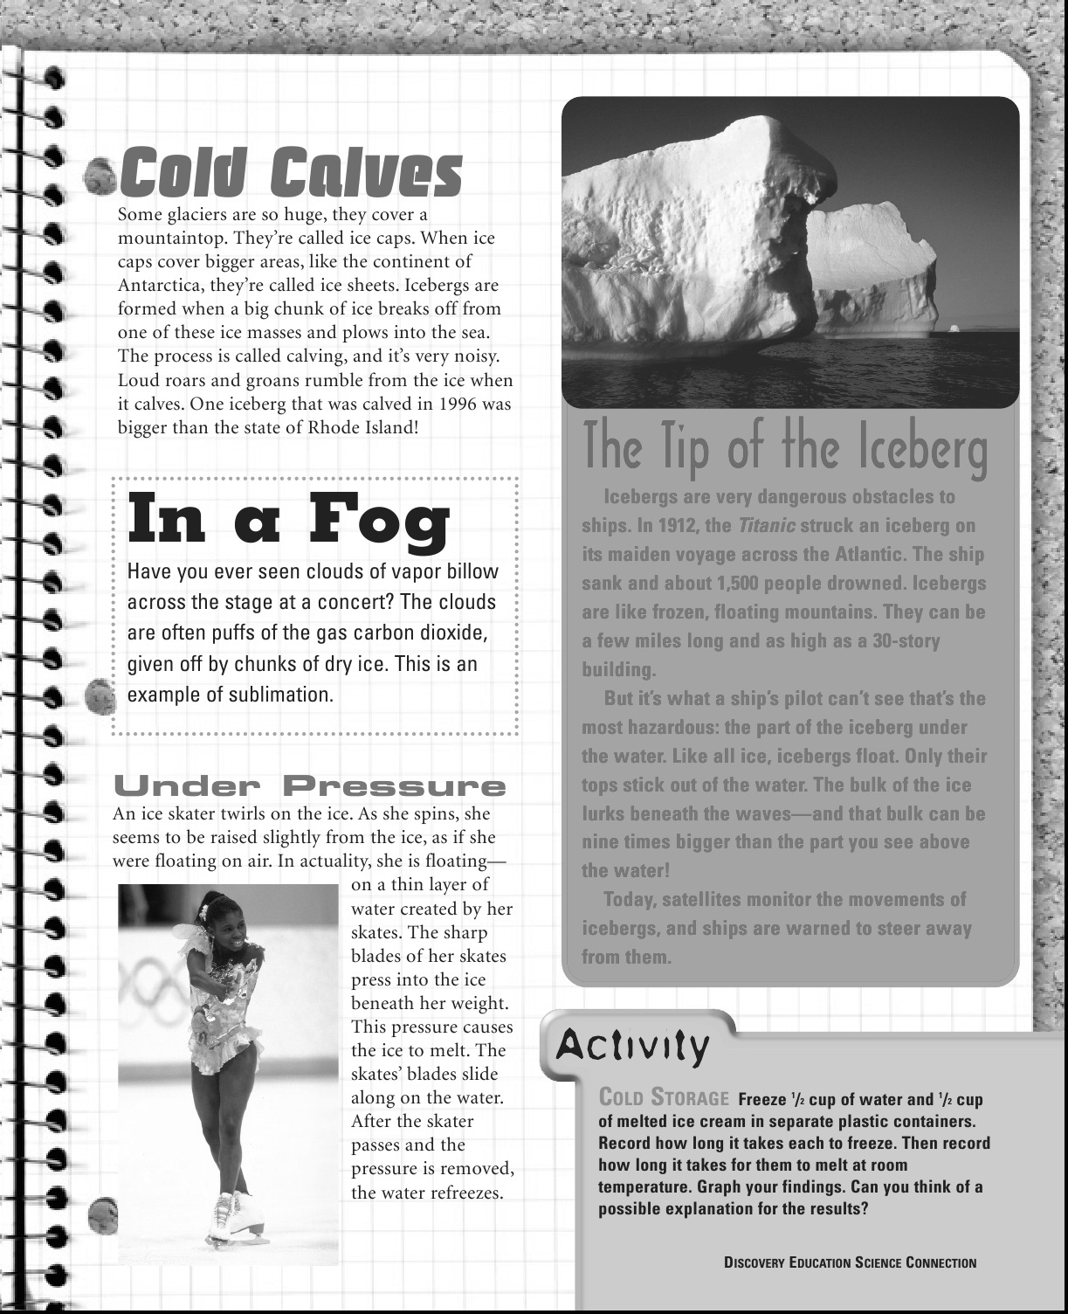

Just for fun!
7. The “calving” process happens when

- sublimation occurs.
- glaciers cover mountaintops.
- chunks of ice break off from an ice cap.
- carbon dioxide is given off by chunks of dry ice.

8. Why does ice float in a glass of water?

- Ice freezes at 32°F.
- Ice is like most solids.
- Ice is colder than the water.
- Ice is less dense than water.

9. How does the appearance of water in different forms impact human activities? Be sure to provide evidence from the reading to support your claim.

Are the Everglades Forever?
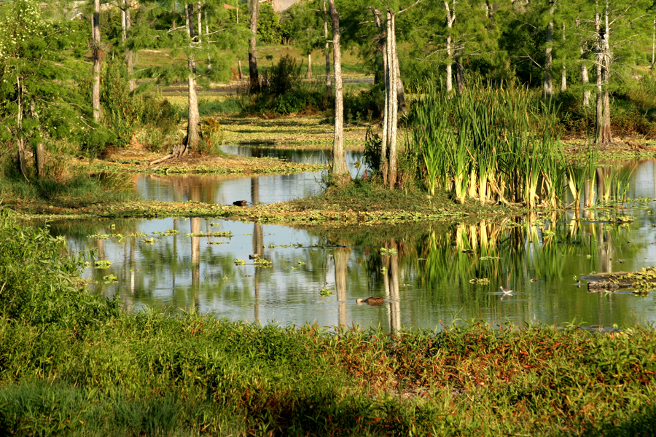
“Snakes,” Indiana Jones hisses through his teeth as he looks into a giant underground cavern. The floor of the pit is moving—thousands of snakes wriggling and writhing over one another. “Why did it have to be snakes?”
It’s a famous scene from the movie “Raiders of the Lost Ark,” in which the main character is confronted by his worst fear. It’s just a movie, but the nightmarish slithering mass is becoming something of a reality in the Florida Everglades. The Everglades, a famous region in Southern Florida, are a wetland ecosystem home to tropical and marshland plant and animal species. The Everglades are a protected national park, but that doesn’t mean that they’re immune to harm. And guess what is one of the most recent and dangerous threats to the ecosystem? Indiana Jones, beware—it is snakes, and they’re big ones.
Reports from just over a year ago say that thousands of pythons have been making their homes in the Everglades at the expense of the native (natural to the area) species. Pythons and anacondas aren’t normal inhabitants of the Florida ecosystem; the ones that have taken over the Everglades are ex-pets and their offspring. While it may seem cool that an exotic pet can survive on its own in an unfamiliar environment, these animals are unwelcome visitors. They’ve managed to upset the natural food chain so drastically that the Everglades are starting to seem a little bit like Indiana Jones’s dreaded snake pit. Besides being creepy, an ecosystem overrun by pythons is unhealthy.
There’s a lot to consider when talking about the health of an ecosystem and to better understand how scientists measure that, it’s helpful to know what some of the buzzwords are. For starters, an ecosystem is defined as a community, characterized by the types of things (plants and animals) that live there; the type of environment around them; and the ways in which they all interact. There are ocean ecosystems, mountain ecosystems, rainforest ecosystems, desert ecosystems and even city ecosystems.
Within those systems, one of the main ways in which animals interact is in the constant search for food. The common term is “food chain,” and it’s a simple way to see how different species rely on one another. An example of a food chain is this: a rabbit eats grass, a snake comes along and eats the rabbit, and a hawk dives down to eat the snake. Food chains can get much longer and more complicated, though, resembling webs more than linear chains. The word commonly used to describe the relative number of different species in an ecosystem is “biodiversity,” and the more biodiversity within the ecosystem, the more complex the food web.
Biodiversity is a good thing. Having many different kinds of plants and animals means that species have different choices for survival. If the simple food chain mentioned above was the only possible choice for the animals involved—if, for instance, snakes could only eat rabbits, and hawks could only eat snakes—then both snakes and hawks would die out, should the rabbit population drop because of an outside factor, like disease. Biodiversity strengthens an ecosystem by ensuring lots of options for hungry animals, from hawks on down to rabbits.
A healthy ecosystem is one in which its plants and animals work in harmony. There are no drastic spikes in the populations of any one species, or drops in another. A large number of different species (a great biodiversity) is one indicator of an ecosystem’s health. Remarkably, biodiversity is not necessarily dependent upon the size of the ecosystem; some of the richest ecosystems in the world exist within narrow boundaries (sections of the Amazon rainforest, for example, and the Galapagos Islands). These ecosystems might be relatively small, but besides threat from destructive human behavior, they’re strong because of their biodiversity; each species is connected to the other in some way.
If a healthy ecosystem is one that is home to many different species, mostly native to the area and all interdependent upon one another, what’s an example of an unhealthy ecosystem? Flashback to Florida; let’s take a closer look at the Everglades. The invasive (not original to a specific environment) pythons and anacondas mentioned earlier are a huge problem—literally. These reptiles can reach lengths of up to 20 feet, which is longer than three adult men lying head-to-toe. At such a size, they have few natural predators, so their numbers grow with little to keep them under control. The snakes compete with alligators for food, even making a meal of a gator once in a while. They’ve crippled the Everglades’ populations of opossums, rabbits, bobcats and foxes, thus dominating the food web to such a degree that there’s not much of a web anymore.
Invasive pythons aren’t the only non-native species that threaten the Everglades ecosystem. There are invasive plants too, hurting the balance of the Everglades, not only choking out native species (some vine-like plants actually grow over original trees and plants), but growing so thick that they block water flow and movement of animals.
Why should humans worry about the Everglades? The loss of the area’s biodiversity doesn’t just hurt the plants and animals that originally made their homes there. Humans have benefited from the Everglades in many ways, from the creation of park and tourism jobs to the water supply that keeps the cities and agriculture of Southern Florida running. If the wetlands suffer, so do humans.
A damaged ecosystem is not hopeless, however. Living things, both as individuals and as systems, have resilience (the ability to recover from harm), and can bounce back from damaging situations, especially if they have some help cleaning up the mess. In the case of the Everglades, people are already beginning to work on stopping and reversing the problems that threaten the life of the ecosystem with hopes for a healthier future. For example, people are spreading the word against disposing unwanted pets, such as pythons, in the wild. They warn others about the consequences of releasing these animals in the wild. These consequences include the threat posed to the survival of native species in the Everglades.
Additionally, scientists and members of the government have initiated a plan to restore the Everglades to a healthier state of being, called the Comprehensive Everglades Restoration Plan (CERP). Every year, the Everglades lose some of their water to the coast simply by draining from the wetlands to the sea. The water loss is more than the ecosystem can keep up with; urban and agricultural systems suffer from water shortages, too. The CERP will restore a lot of the water by opening up unused dams and filling in old canals to help redirect water flow back to the wetlands.
So, between focused efforts by scientists and the public alike to help stop invasive species from taking over and efforts like the CERP to improve the Everglades’ landscape, improvement is possible. As the Everglades become a more livable environment, it will be easier for species to recover along with the land. And, as the ecosystem finds a balance, humans will be able to keep using the land’s resources, both for work and play.
© 2013 ReadWorks®, Inc. All rights reserved.

10. A problem explained in the passage about the Everglades is that water is lost along the coast
due to draining. What is a possible solution to this problem?

- Creating more parks and tourism jobs for humans.
- Release more pythons in the Everglades
- Start the Comprehensive Everglades Restoration Plan.
- Introduce invasive plants in the Everglades’ ecosystem.

11. Read the following excerpt from the passage: “Humans have benefited from the Everglades in

many ways, from the creation of park and tourism jobs to the water supply that keeps the cities and agriculture of Southern Florida running. If the wetlands suffer, so do humans.”

Based on the evidence in this excerpt, how might humans suffer when wetlands suffer?

- They may stop creating national parks in Florida to protect the wetlands.
- They may be disappointed when they can no longer see pythons in the wild.
- The may lose access to good jobs and safe water supplies for drinking and farming.
- They may lose access to alligators and other animals as food supplies.
12. What solution is mentioned in the passage that is making improvement in the Everglades. Why are humans interested in improving the Everglades? Be sure to provide evidence from the reading to support your claim.

Grade 8 Winter Enrichment Packet Answer Key

1. A
2. D
3. Use the NSTA rubric to score your writing response.
4. D
5. C
6. Use the NSTA rubric to score your writing response.
7. C
8. D
9. Use the NSTA rubric to score your writing response.
10. C
11. C
12. Use the NSTA rubric to score your writing response.

Use the rubric below to score items #3, #6, #9 and #12.

National Science Teachers Association: Claim, Evidence, and Reasoning Rubric for Writing
Score | Claim  A statement or conclusion that answers the original question/problem. | Evidence  Scientific data that supports the claim. The data needs to be appropriate and sufficient to support the claim. | Reasoning  A justification that connects the  evidence to the claim.  It shows why the data counts as evidence by using appropriate and sufficient scientific principles.
4 | All aspects of level 3 included and is written in a way that engages the reader. | All aspects of level 3 included; correctly identifies the sources and is written in a way that engages the reader. | All aspects of level 3 included and is written in a way that engages the reader.
3 | Makes an accurate and complete claim and includes points from the question in the writing. | Provides all or most of the expected pieces of evidence from the sources used in an appropriate manner. | Provides reasoning components for all or most of the evidence and explains how the evidence supports the claim.
2 | Makes an accurate and  complete claim. | Provides some of the expected pieces of evidence from the sources used (e.g., data like numbers, observations, etc.) in an appropriate manner. | Provides reasoning components for some of the evidence and explains how the evidence supports the claim.
1 | Makes an accurate but vague  or incomplete claim. | Makes a general statement regarding evidence, but does not include specific details. | Repeats evidence and links it to the claim, but does not explain how the evidence supports the claim.
0 | Does not make a claim, or  makes an inaccurate claim. | Does not provide evidence, or only provides inappropriate evidence or vague evidence, like “the data shows me it is true.” | Does not provide reasoning or only provides inappropriate reasoning.

